Party Leaders
Liberal Party
Brian Gallant
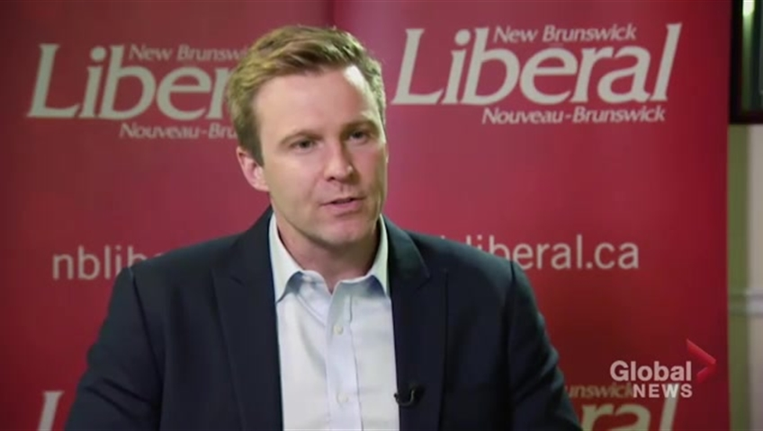

Progressive Conservative(PC)
Blaine Higgs

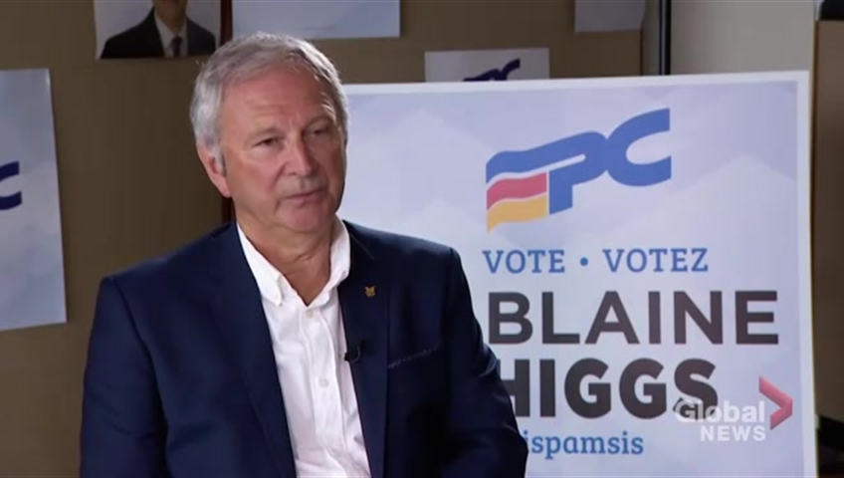

Green Party
David Coon
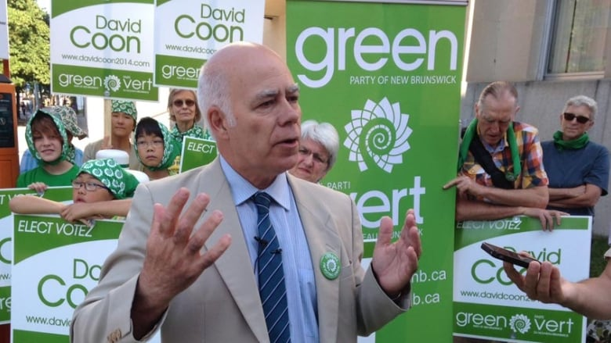

New Democratic Party (NDP)
Jennifer McKenzie

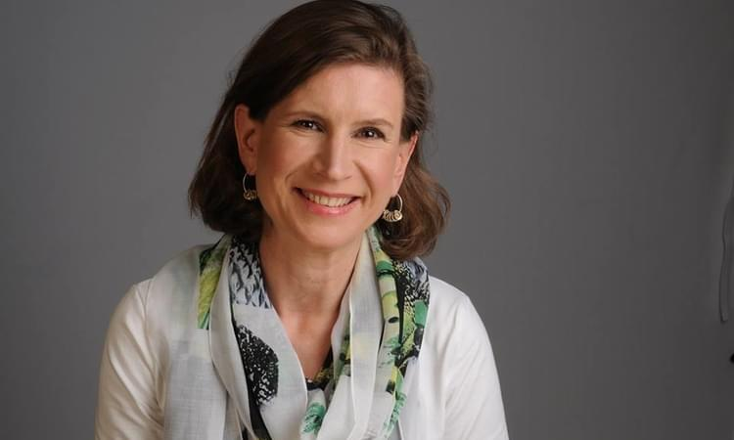

People’s Alliance
Kris Austin

